**Executive Summary:**

The purpose of this report is to examine the tuition fee of US colleges based on number of characteristics. The dataset consists of a sample data collected from 1121 records and includes the following variables (prefixed by their column name in the data file):

* tuition: College tuition ("out-of-state" rate for those with in-state discount).
* pcttop25: Percent of new students from the top 25% of high school class.
* sf_ratio: Student to faculty ratio.
* accrate: Fraction of applicants accepted for admission.
* graduat: Percent of students who graduate.
* pct_phd: Percent of faculty with Ph.D.'s.
* fulltime: Percent of undergraduates who are full time students.
* alumni: Percent of alumni who donate.
* num_enrl: Number of new students enrolled.
* public_private: Is the college a public or private institution? public=0, private=1
* fac_comp: Average faculty compensation.

**Abstract:**

In this project, we will perform data mining processes on a dataset of tuition covering all the other factors of colleges in calculation and prediction. The objective of this project is to create a predictive model of college tuition based on a number of characteristics gathered from higher education institutions.

We will perform data mining process addressing the following points:

1. **Explore the data to get some initial insights, if you think it is useful (your call):**

Our first step is to have a visual of some of the data, these will give us a rough idea about now the data is connected to each other, how the data is flowing from one variable to other. In our exploratory data analysis, we explored this phase and the data preparation phase simultaneously in order to utilize the new ideas of how to graphically explore the data every time the new areas of the data are uncovered.

Firstly, we performed a data audit on our provided CVS file. We have found that the data set is not complete has lots of missing values across different fields. We will start by having visuals of some of fields on these data set, below is the attached snapshot of it:





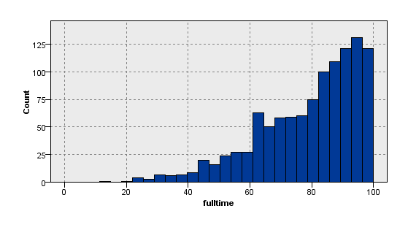

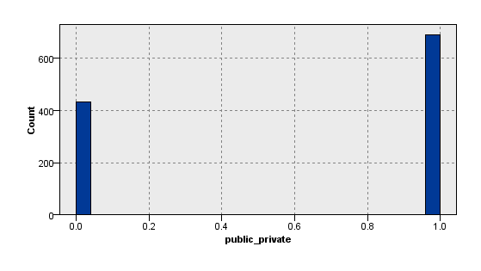

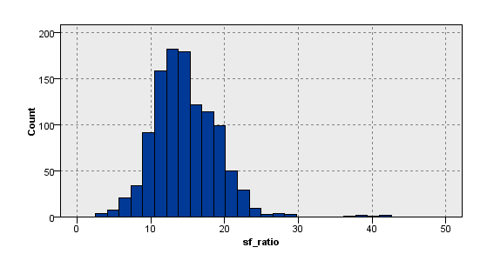

1. **Identify outliers and decide what to do with them:**

Data Audit node report the outliners, defined here as values between 3 and 5 standard deviations from the mean, in the following fields: tuition, sf_ratio, accrate, graduat, pcr_phd, full time, alumni, num_enrl, fac_comp. There were values exceeding 5 standard deviations from the mean in the fields: Accrate, pct_phd, fulltime, num_enrl and fac_comp.

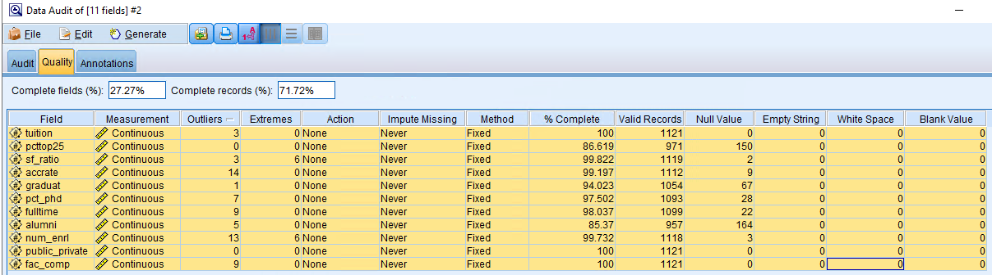



1. **Missing data appears to be a problem with this data set. Prepare a copy of the dataset, where the missing values are each replaced with their field means. Report on how this substitution has affected the fields (summary stats, etc.), if at all. What do you think of this method of dealing with missing values?**

First let’s have a visual of missing dataset, the snapshot is attached below:

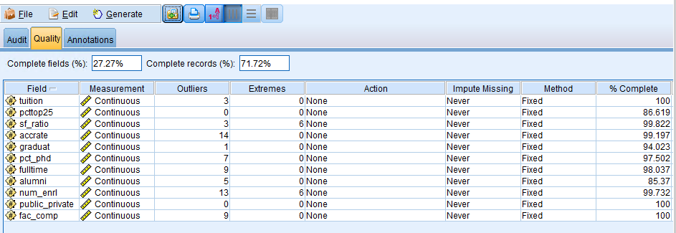

From the above we can see that the data is not complete, so now we will generate a missing node with addressing all the missing imputes by their mean

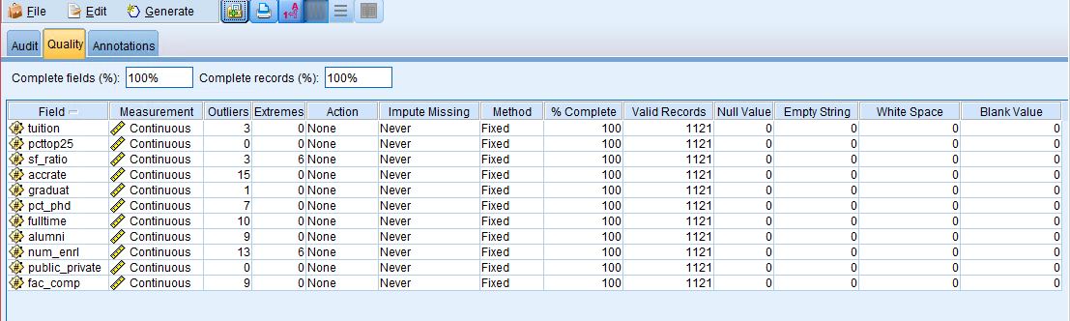

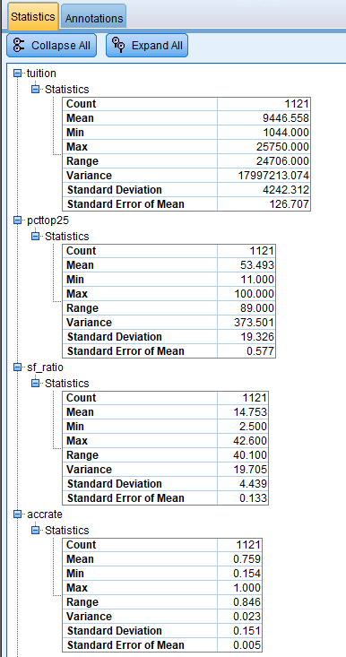Below is complete summary stats of dataset after handling the missing values.

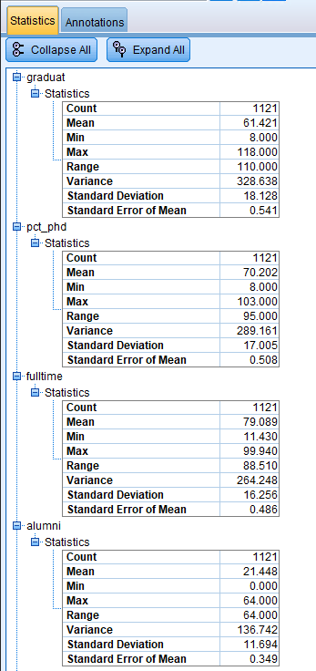

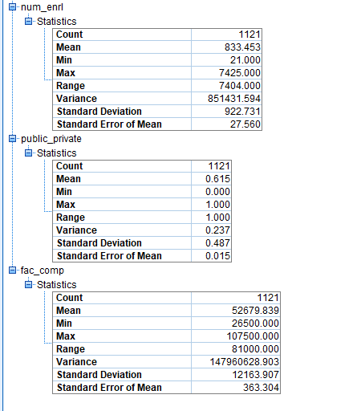

Using the mean of the field seems the best option to complete the missing values, if we have deal with complete data set, but mean field will only give us a projected value for that specific field, for this part of the project mean field seems to the best option.

1. **Provide a table describing the relationship of each explanatory variable with tuition (hint: use scatter plots). If the relationship is not linear, you can1 make it so by transforming the predictor variable.**

In order to describe the relationship of each variable we first start by having the visual of the data, below is the scatter plot of **tuition vs Pcttop25.** For this part of the project we have used the original data set with missing values to the graphical representation.



The above data for percent of new student from top 25% of high school class on the y axis and tuition on the x axis seems a bit skewed, but can have out idea that higher percentage of new students from top 25% of high school class has higher tuition fee. Let’s have a log transformed y axis (percentage of new students from top 25% of high school class).



The above graph gives us a idea that with increase in percentage of new students from top 25% of high school class we have a increase in tuition fee.

**Looking into the tuition vs staff ratio:**

We first have a simple visual of data in graph.



The above data set is seeming inversely proportional with staff ratio to tuition, let’s try to transform the staff ratio axis if that makes the graph more logical and understandable.



In the above graph, we have used the square transformation for staff ratio, the graph is still bit skewed but have a visual understanding that with the increase in tuition fee we have decrease in staff ratio.

**looking into tuition vs accurate:**



The above graph is skewed is hard to say anything with the visuals. Let’s try with different transformation representation of the graph.



After different hit and trial, squared transformation for fraction of applicants accepted for admission vs the tuition fee for US universities, we can say the graph is mostly skewed, but we have some density where we can say the fraction of applications accepted are with tuition fee around 5000 to 10000.

**Tuition vs Graduation:**

The theth

From the above graph we can say that the percentage of students who graduated increases with the increase in tuition fee.

**Tuition vs PHD:**



From the above graph we can say that with increase in tuition fee we have an increase in percentage of faculty who have a Ph.D.’s. Let’s have transformed y axis if we have more clear visual.



The above graph is still skewed but we can say that with the increase in tuition fee we have more percentage of faculties with PHD degrees from the given data set.

**Tuition vs fulltime** 

The above graph is skewed but get have visual that with the increase in tuition we have a higher percentage of undergrads who are full time students.



From the we can see that we still have skewed graph but we from the visuals we can say that with the increase in tuition fee we have slightly more percentage of undergrads who are full time students.

**Tuition vs Alumni**



The above is the normal graph between tuition on the x axis and alumni – percentage of alumni who donate. We can say that with the increase in percentage of donation we have increase in tuition fee as well. Let’s try a log transformation of y axis we have clearer visual.

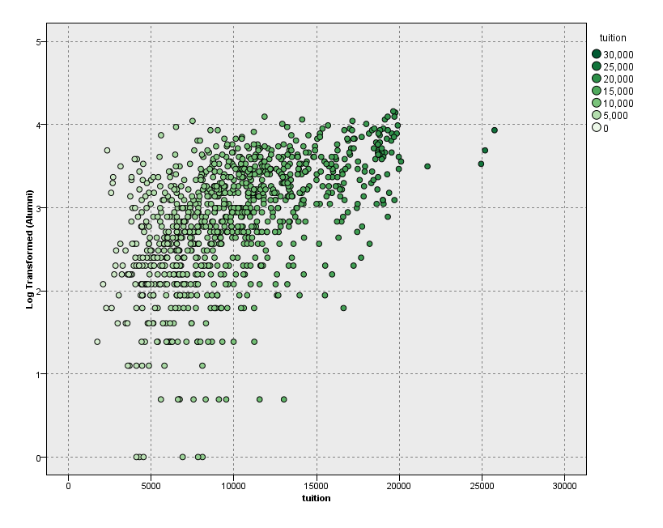

From the above graph we can say that we the increase in percentage of donation we have increase in tuition fee as well.

**Tuition vs number of new students enrolled:**



The above graph is very skewed is not possible to say anything from the visual, let try some transformations.



With the log transformation of number of new students enrolled we can say that we have a greater number of new students enrolled with tuition fee increasing mostly between 8000 – 15000.

**Tuition vs Public Private:**



As we have a binary data for tuition vs public = 0 and private =1, we can say that private schools have more higher tuition fee as compared to the public schools.

**Tuition vs average faculty Compensation:**



From the above we can say that with the increase in tuition fee we have a increase in average faculty compensation, lets try some transformation if we can get more clear visuals.



The above graph is still bit skewed but we can say that with the increase in tuition fee we have increase in average compensation of faculty.

1. **Investigate the correlation among the predictor variables. Suggest a creative course of action (rather than simply omitting a variable) for dealing with any medium or strong correlations encountered (e.g. textbook, section 9.7; avoid any method linked to principal component analysis, as we have not covered it yet).**

The correlation among the predictor can be seen using statics node with given data set.

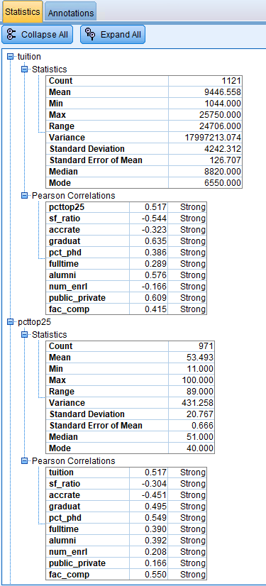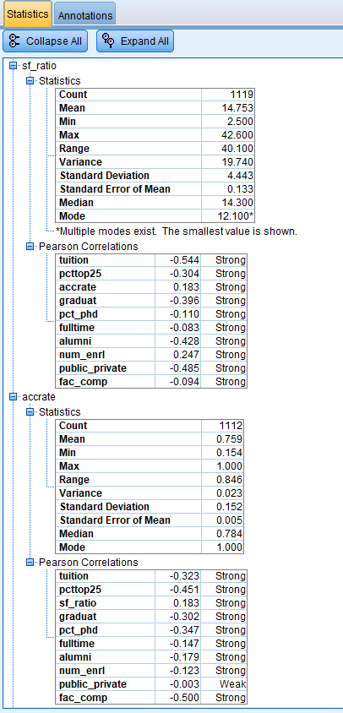

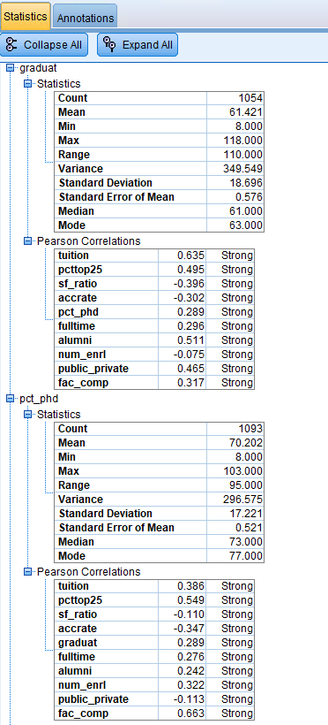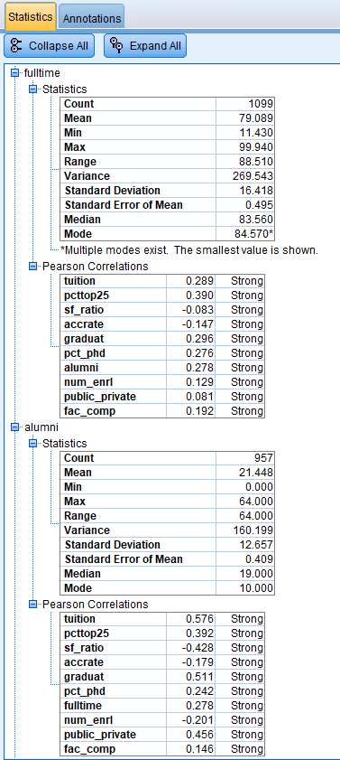

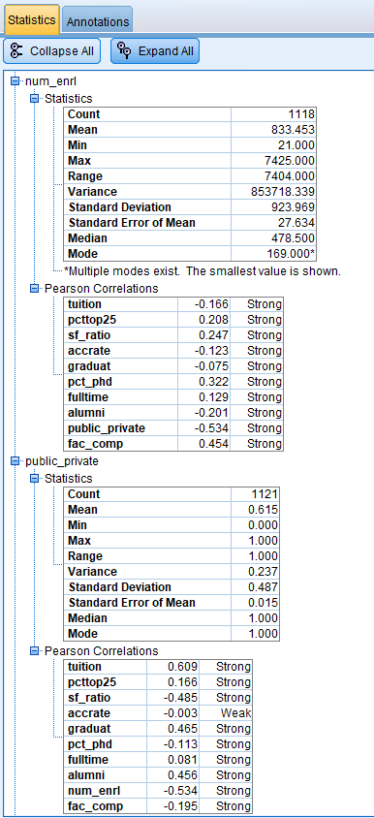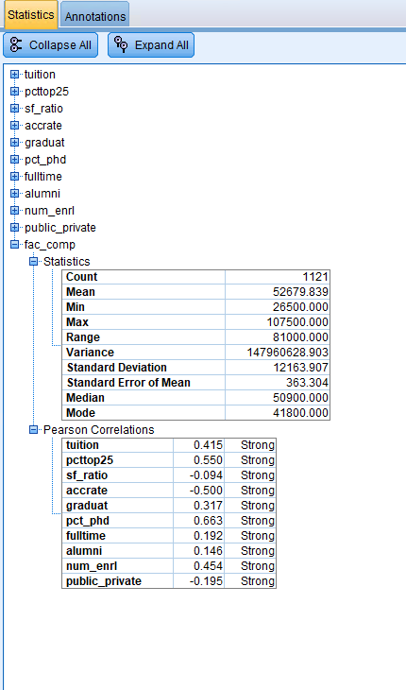

The above we have noticed that we have strong correlation in the fields for College tuition, percentage of new students from the top 25% of high school class, percentage of alumni who donate and in public and private college fields.

1. **Use SPSS Modeler linear regression tool to investigate whether a linear relationship exists between tuition and the other variables. Investigate the differences in the models, if any, among these methods: enter, stepwise, backwards. Construct a table showing method, variables included, statistical tests on regression coefficients, goodness of fit metric(s), predictive accuracy metric on training and test data. Discuss. Which model do you prefer and why?**

For this part of the question before modeling the data, we have first divided the given data set into 70: 30 ratios for Training and Testing, snapshot has been attached below:

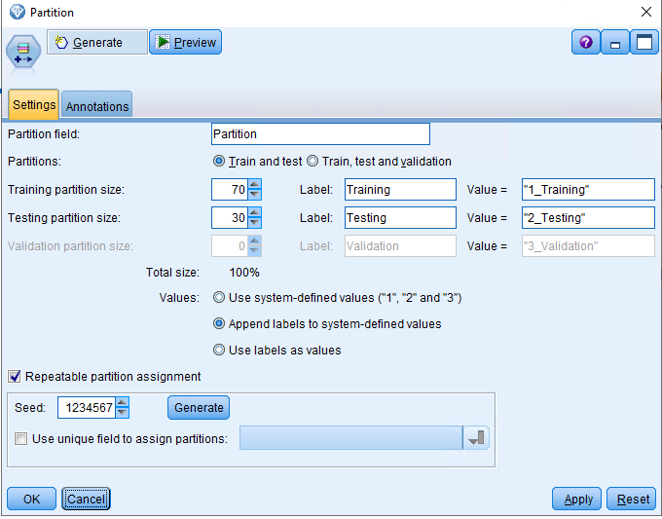

Then we have used the type node to read values of dataset, below is the attached snapshot:

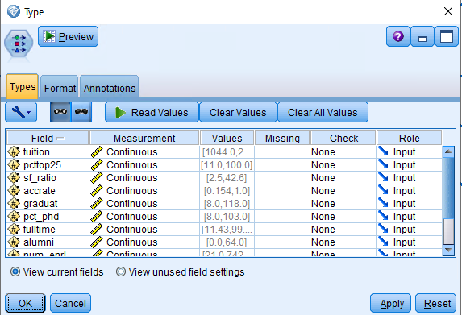

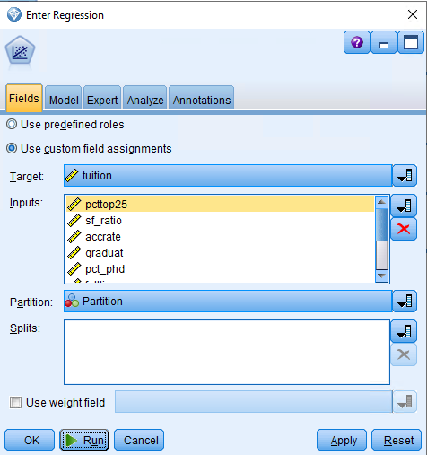The next step is to perform the Regression from SPSS, we have first have started with Enter Regression the choices for implementing the Enter regression is attached below:

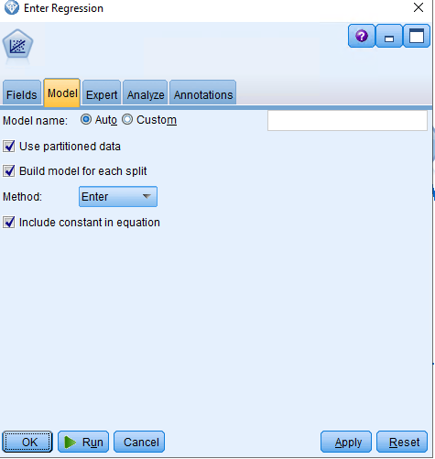

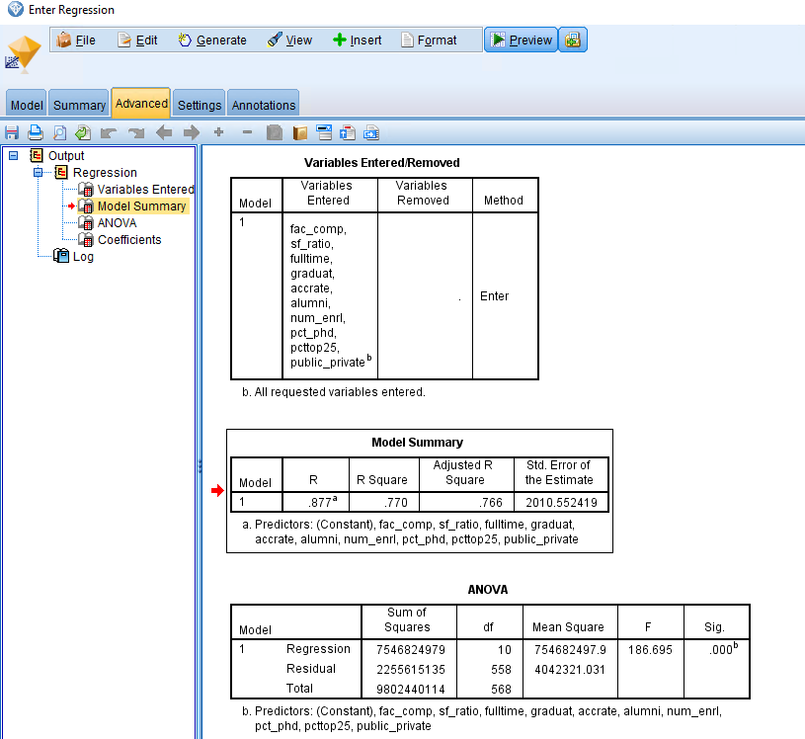

From the above model we have R value = 87.7, R squared value = 76.6 and F value is 186.695. From the above regression we can also say that the both of the regression coefficients are statically significant. We know that because the significant value obtain from the above regression is 0.000 which indicates that p < 0.001.

Now let’s perform the Stepwise regression using the same parameter, we have the below Model summary:

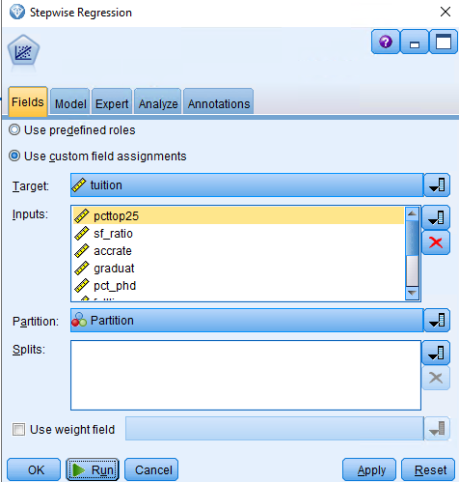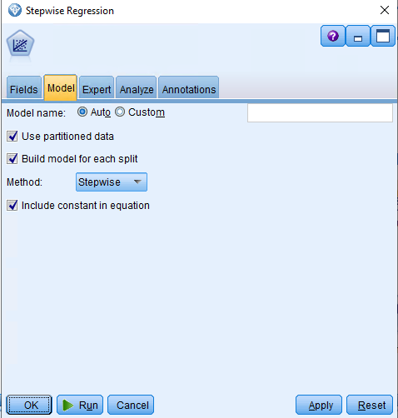

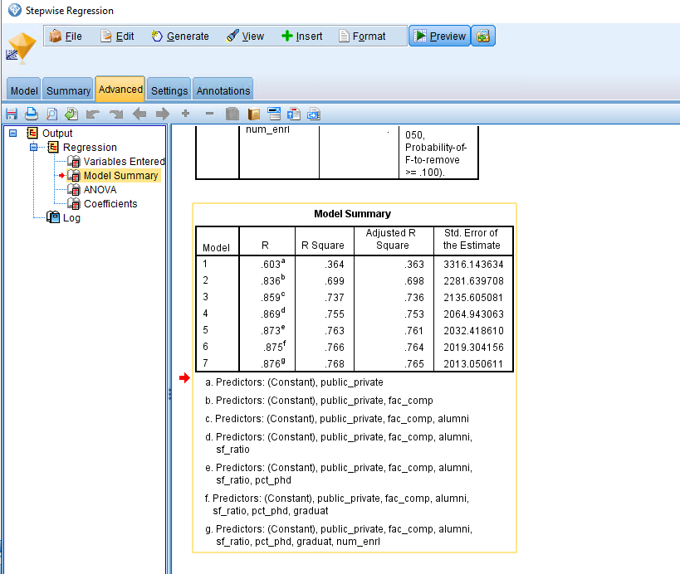

From the above model we have R value = 87.6, R squared value = 76.8 and F value is 186.695. From the above regression we can also say that the both of the regression coefficients are statically significant. We know that because the significant value obtain from the above regression is 0.000 which indicates that p < 0.001.

Now let’s perform the backward regression using the same parameter, we have the below Model summary:

Now let’s perform the backward Regression:

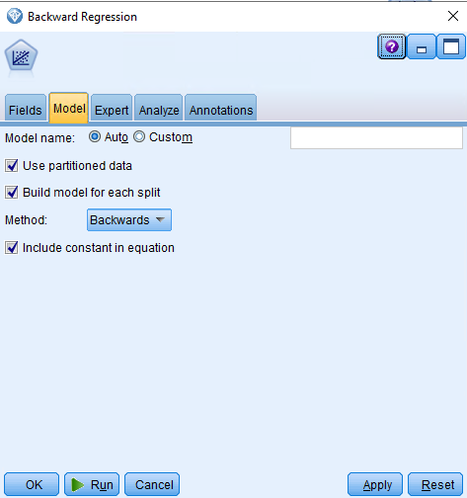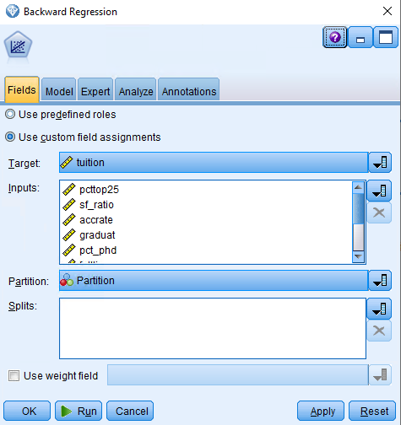

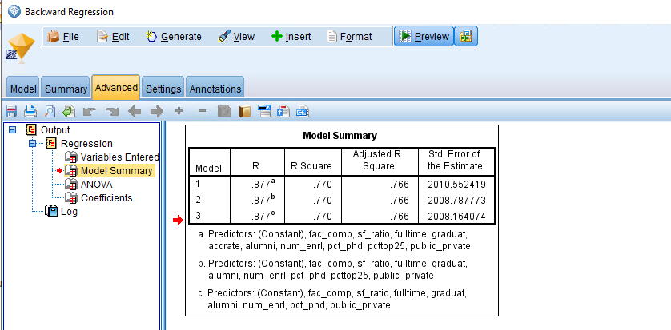

From the above model we have R value = 87.7, R squared value = 77 and F value is 185.95. From the above regression we can also say that the both of the regression coefficients are statically significant. We know that because the significant value obtain from the above regression is 0.000 which indicates that p < 0.001.

From the above three models we have similar values for R, R squared value, F and P values. If we have to choose a model we would move forward or select stepwise model, just because of its model processing, as step wise model is estimated on every step and we would select the stepwise model from the above 3 models. Below are the complete details stats for stepwise model.

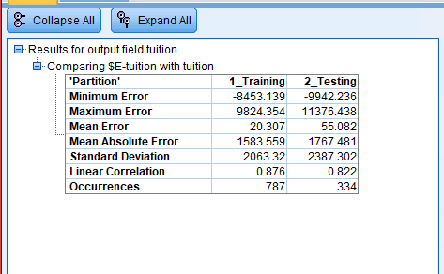

We will discuss more in details about the above stats and graph is below question number 9.



1. **Use SPSS Modeler linear regression tool on the data set where the missing values are each replaced with their field means. Investigate the differences in the models, if any, among these methods: enter, stepwise, backwards. Construct a table showing method, variables included, statistical tests on regression coefficients, goodness off its metric(s), predictive accuracy metric on training and test data. Discuss. Which model do you prefer and why?**

For this part of the question before modeling the data, we have first divided the given data set into 70: 30 ratios for Training and Testing, then will perform the enter, stepwise and backward regressions on our data set after handling the missing data. Below is the snapshot for each regression models.

**Starting with Enter Regression:**

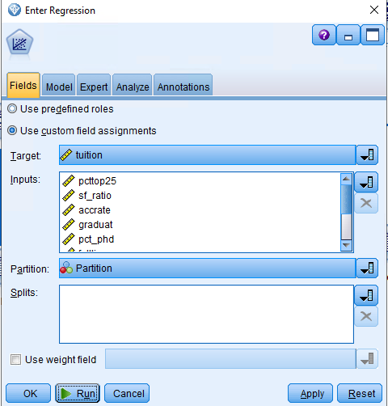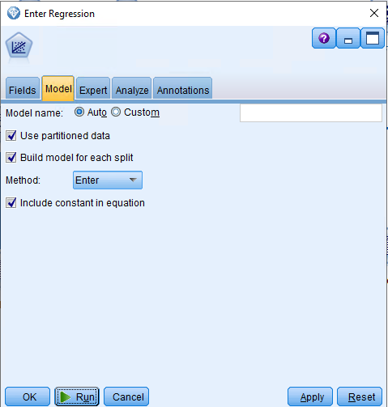

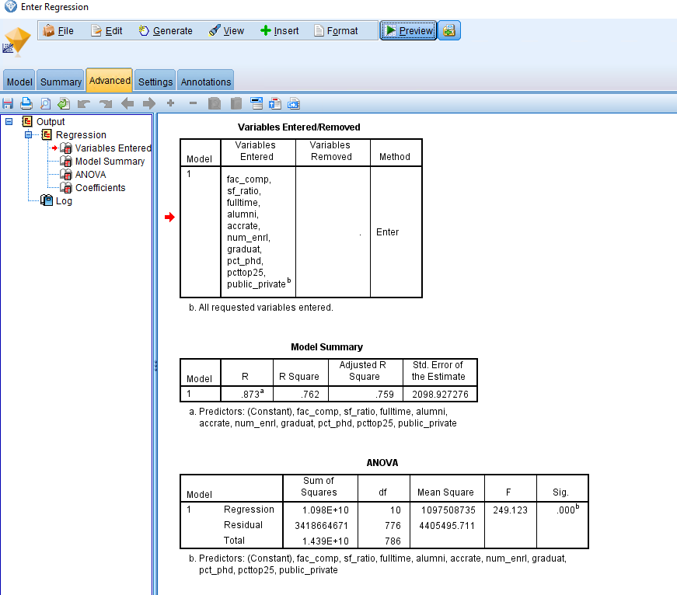

From the above model we have R value = 87.3, R squared value = 75.9 and F value is 249.123. From the above regression we can also say that the both of the regression coefficients are statically significant. We know that because the significant value obtain from the above regression is 0.000 which indicates that p < 0.001.

**Stepwise Regression:**

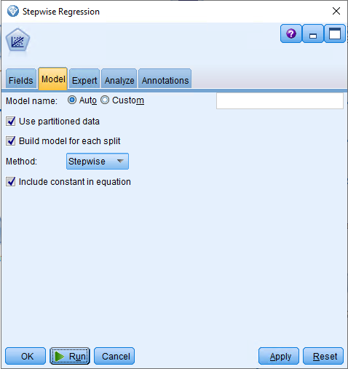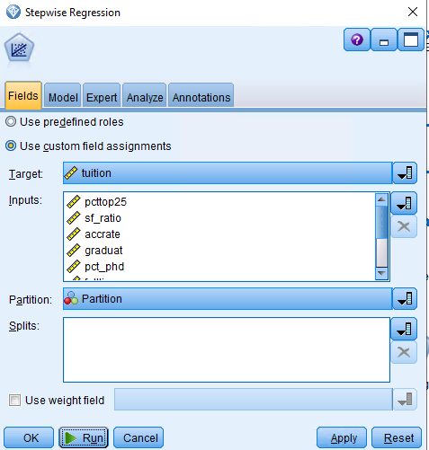

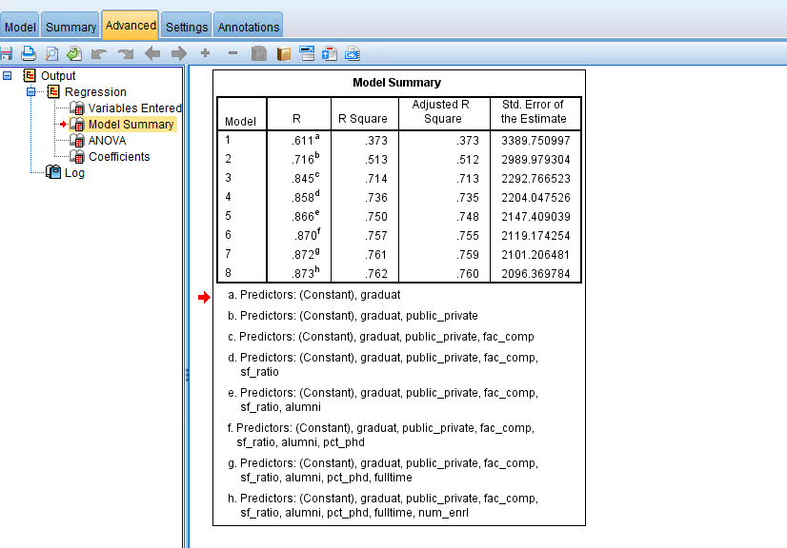

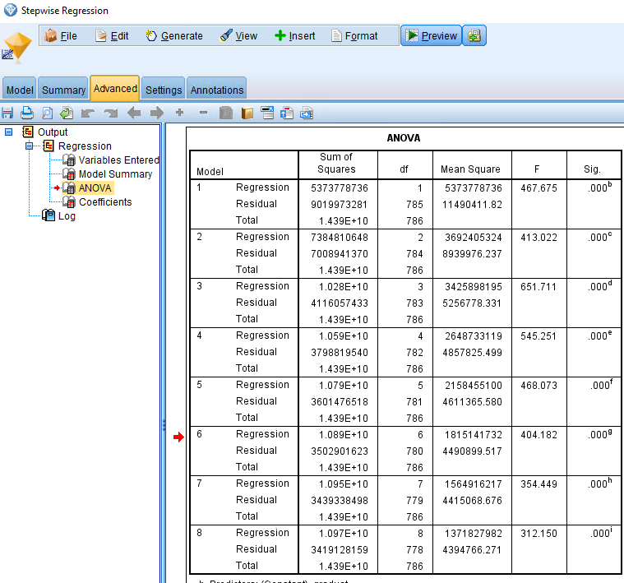

From the above Stepwise Regression model, we have R value = 87.3, R squared value = 76.2 and F value is 312.150. From the above regression we can also say that the both of the regression coefficients are statically significant. We know that because the significant value obtain from the above regression is 0.000 which indicates that p < 0.001

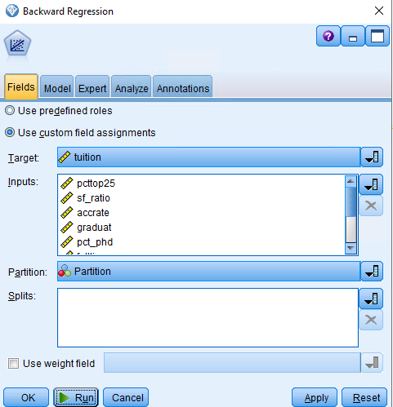**Backward Regression:**

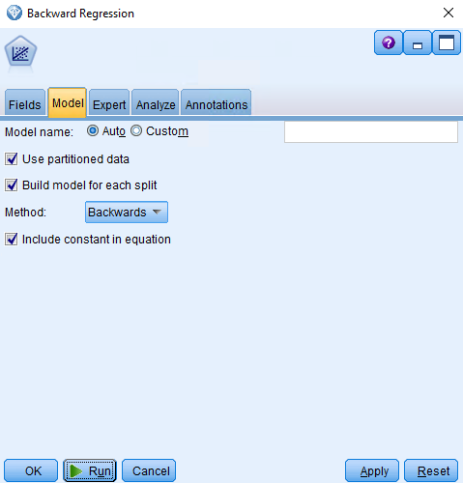

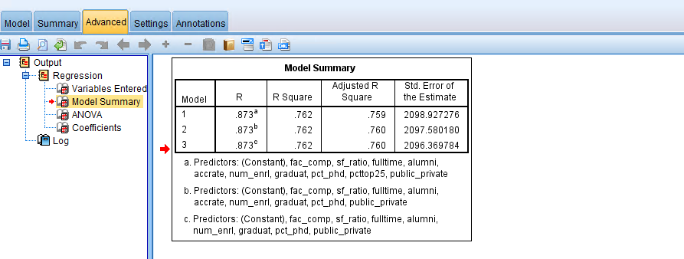

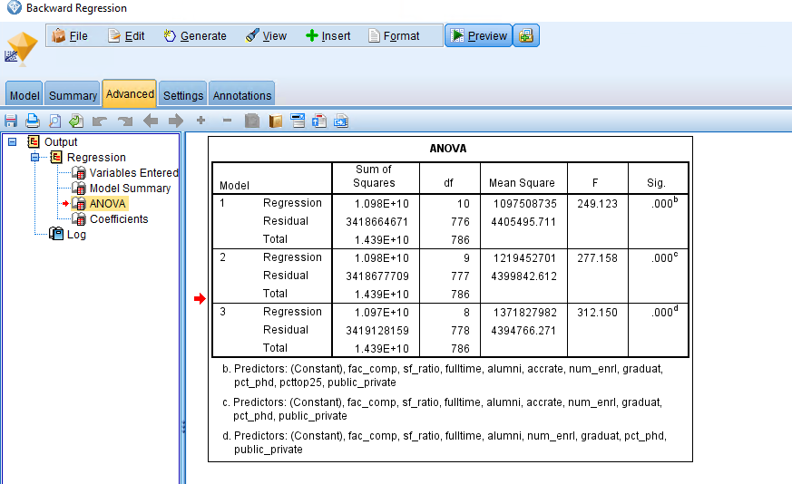

From the above backward Regression model, we have R value = 87.7, R squared value = 76.2 and F value is 312.150. From the above regression we can also say that the both of the regression coefficients are statically significant. We know that because the significant value obtain from the above regression is 0.000 which indicates that p < 0.001.

From the above three models we have similar values for R, R squared value, F and P values. If we have to choose a model we would move forward or select stepwise model, just because of its model processing, as step wise model is estimated on every step and we would select the stepwise model from the above 3 models. Below are the complete details stats for stepwise model.

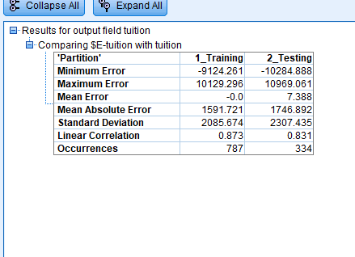 

1. **Compare the best model in 6 and the best model in 7. Which model do you prefer and why?**

After comparing two models which are stepwise model with missing values and stepwise regression model without missing values, if we have the choose a model we would choose the model with missing values just because taking a mean for the important features for predicting a model, and we had approximately 76 % complete data set, rest of them are with missing values. If the missing values feature we less than 5% then we might would have choose Regression model with after handling the missing data. But for the given conditions and data set, we would go with the Stepwise Regression model with missing values as it would be best the best model for predicting.

1. **For the final (chosen) model:**
2. **Write out the estimated regression equation and explain the meaning of the coefficients**

Tuition = (-3774.1) +

sf_ratio * -154.5 +

Graduate* 18.4 +

Pct_phd * 25.46 +

Fulltime * 19.94 +

Alumni * 36.9 +

Num_enrl * - 0.2562 +

Public_private * 4416.5 +

Fac_comp * 0.1464 +

* An intercept of -3774.1 has no interpretation as it would be the tuition fee of university based on different factors included in the data set.
* A slope of -154.5 in sf-ratio means that with each increase in tuition fee the ratio of student to faculty reduces by 154.5.
* A slope of 18.4 in graduate means that with increase in tuition fee the percentage of students who graduated increases by 18.4%.
* A slope of 25.46 in pct_phd means that with increase in tuition fee the percentage of faculty with PHD’s increases by 25.46%.
* A slope of 19.94 in fulltime means that with increase in tuition fee the percentage of undergraduates who are full time students increases by 19.94%.
* A slope of 36.9 in alumni means that with increase in tuition fee the percentage of alumni who donate increases by 36.9%.
* A slope of (-0.2562) in num_enrl means that with increase in tuition fee the number of new students who enrolled decreases by 0.2562.
* A slope of (4416.5) in public_private has no interpretation as it would be the tuition fee of university based on public = 0 and private = 1, from the graphical representation in question 3, we have seen that private universities have more tuition fee as compared with to public universities.
* A slope of 36.9 in alumni means that with increase in tuition fee the percentage of alumni who donate increases by 36.9%.
* A slope of 0.146 in fac_comp means that with the increase in tuition fee the average compensation of faculty increases by 0.146.

1. **Provide a full report of the chosen regression model and report its metrics (goodness of fit, predictive performance) and statistics on training and test data Make sure you tweak your models to get the best performance. Use 70/30 partition in all cases**

Below is the complete metrics report of the chosen model

|  |  |  |  |  |
| --- | --- | --- | --- | --- |
| Model Summary | | | | |
| Model | R | R Square | Adjusted R Square | Std. Error of the Estimate |
| 1 | .611a | .373 | .373 | 3389.750997 |
| 2 | .716b | .513 | .512 | 2989.979304 |
| 3 | .845c | .714 | .713 | 2292.766523 |
| 4 | .858d | .736 | .735 | 2204.047526 |
| 5 | .866e | .750 | .748 | 2147.409039 |
| 6 | .870f | .757 | .755 | 2119.174254 |
| 7 | .872g | .761 | .759 | 2101.206481 |
| 8 | .873h | .762 | .760 | 2096.369784 |
| a. Predictors: (Constant), graduat | | | | |
| b. Predictors: (Constant), graduat, public_private | | | | |
| c. Predictors: (Constant), graduat, public_private, fac_comp | | | | |
| d. Predictors: (Constant), graduat, public_private, fac_comp, sf_ratio | | | | |
| e. Predictors: (Constant), graduat, public_private, fac_comp, sf_ratio, alumni | | | | |
| f. Predictors: (Constant), graduat, public_private, fac_comp, sf_ratio, alumni, pct_phd | | | | |
| g. Predictors: (Constant), graduat, public_private, fac_comp, sf_ratio, alumni, pct_phd, fulltime | | | | |
| h. Predictors: (Constant), graduat, public_private, fac_comp, sf_ratio, alumni, pct_phd, fulltime, num_enrl | | | | |

|  |  |  |  |  |  |  |
| --- | --- | --- | --- | --- | --- | --- |
| **ANOVA** | | | | | | |
| Model | | Sum of Squares | df | Mean Square | F | Sig. |
| 1 | Regression | 5373778736.398 | 1 | 5373778736.398 | 467.675 | .000b |
| Residual | 9019973281.414 | 785 | 11490411.823 |  |  |
| Total | 14393752017.812 | 786 |  |  |  |
| 2 | Regression | 7384810647.687 | 2 | 3692405323.844 | 413.022 | .000c |
| Residual | 7008941370.125 | 784 | 8939976.237 |  |  |
| Total | 14393752017.812 | 786 |  |  |  |
| 3 | Regression | 10277694584.560 | 3 | 3425898194.853 | 651.711 | .000d |
| Residual | 4116057433.252 | 783 | 5256778.331 |  |  |
| Total | 14393752017.812 | 786 |  |  |  |
| 4 | Regression | 10594932477.866 | 4 | 2648733119.467 | 545.251 | .000e |
| Residual | 3798819539.946 | 782 | 4857825.499 |  |  |
| Total | 14393752017.812 | 786 |  |  |  |
| 5 | Regression | 10792275500.092 | 5 | 2158455100.018 | 468.073 | .000f |
| Residual | 3601476517.720 | 781 | 4611365.580 |  |  |
| Total | 14393752017.812 | 786 |  |  |  |
| 6 | Regression | 10890850394.600 | 6 | 1815141732.433 | 404.182 | .000g |
| Residual | 3502901623.212 | 780 | 4490899.517 |  |  |
| Total | 14393752017.812 | 786 |  |  |  |
| 7 | Regression | 10954413519.574 | 7 | 1564916217.082 | 354.449 | .000h |
| Residual | 3439338498.238 | 779 | 4415068.676 |  |  |
| Total | 14393752017.812 | 786 |  |  |  |
| 8 | Regression | 10974623858.588 | 8 | 1371827982.324 | 312.150 | .000i |
| Residual | 3419128159.224 | 778 | 4394766.271 |  |  |
| Total | 14393752017.812 | 786 |  |  |  |
| b. Predictors: (Constant), graduat | | | | | | |
| c. Predictors: (Constant), graduat, public_private | | | | | | |
| d. Predictors: (Constant), graduat, public_private, fac_comp | | | | | | |
| e. Predictors: (Constant), graduat, public_private, fac_comp, sf_ratio | | | | | | |
| f. Predictors: (Constant), graduat, public_private, fac_comp, sf_ratio, alumni | | | | | | |
| g. Predictors: (Constant), graduat, public_private, fac_comp, sf_ratio, alumni, pct_phd | | | | | | |
| h. Predictors: (Constant), graduat, public_private, fac_comp, sf_ratio, alumni, pct_phd, fulltime | | | | | | |
| i. Predictors: (Constant), graduat, public_private, fac_comp, sf_ratio, alumni, pct_phd, fulltime, num_enrl | | | | | | |

Statistical tests on Regression Coefficients for Stepwise Method:

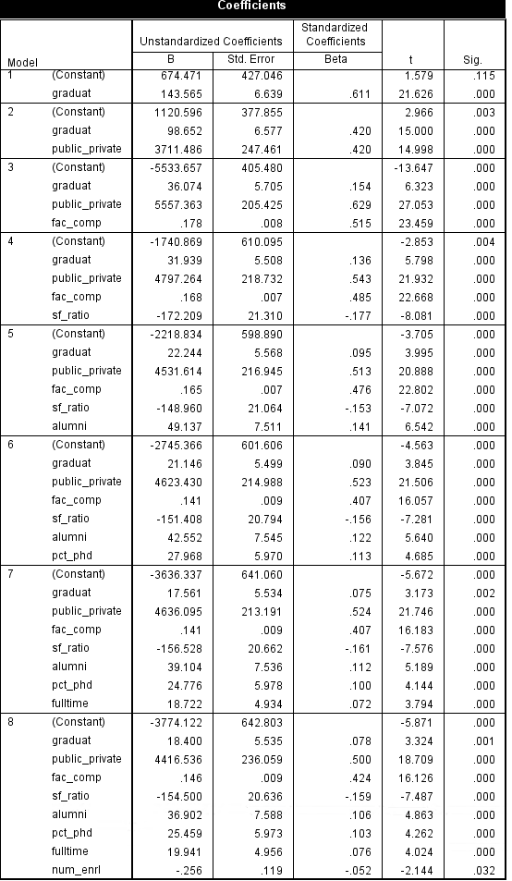

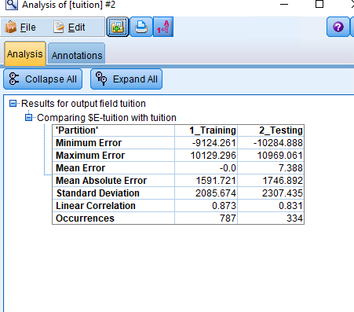



1. **Decision tree classification: Using the public_private variable as categorical (flag), or deriving from it a flag variable, model the profile of a typical public and private college with a C5.0 decision tree algorithm, using all other variables as predictors (disregard tuition, given the typical difference in tuition between state and private institutions). Compute the confusion matrix and derive proper performance metrics.**

The data set is unbalanced, as there are more private university 61.46 % which is 689 than compared to public university 38.54% which is 432.





The decision tree can be built as below:

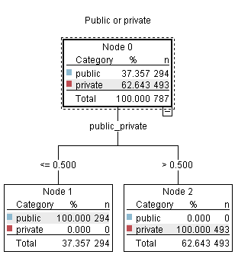

Decision Rules:

|  |  |  |  |
| --- | --- | --- | --- |
| If | Consequence | Support | Confidence |
| If university = public | Public <= 0.500 | 294/ 787 | 294/ 787 = 37.357% |
| If university = private | Private < 500 | 493/ 787 | 493/ 787 = 62.643 |

Performance Evaluation (1)- Confusion Matrix and Derived Metrics can be given as

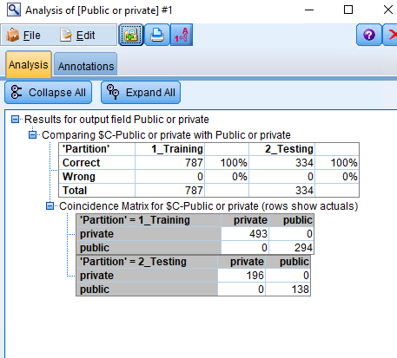

For Testing set:

Since the data set is unbalanced, it is necessary to examine Recall and Precision in addition to the Accuracy:

|  |  |  |
| --- | --- | --- |
| Accuracy | (TP+TN)/(TP+FP+TN+FN) = (196+138)/334 | 100% |
| Recall | TP/(TP+FN) = 196/ (196+0) | 100%% |
| Precision | TP/(TP+FP) = 196/ (196+0) | 100% |
| False Positive  (1 - Specificity) | 1-(TN/(FP+TN)) = 1 - (138/ (0+138)) | 0% |

Performance Evaluation (2) – Gain Chart can be given as:



The above is Gain chart.

Stream for Q 1,2,3 and 7:

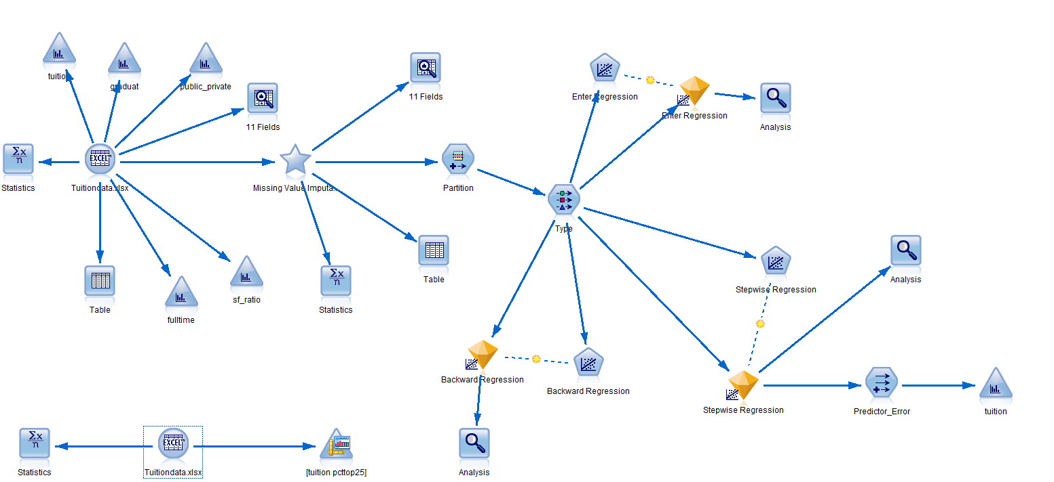

Stream for Question 4:

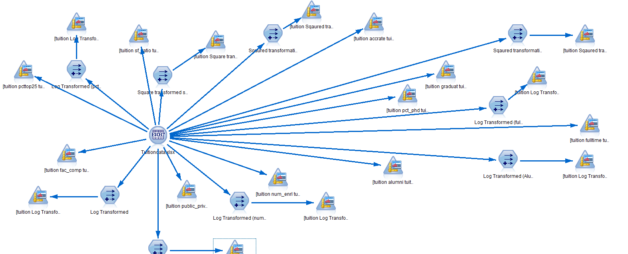

Stream for Q5 and Q6:

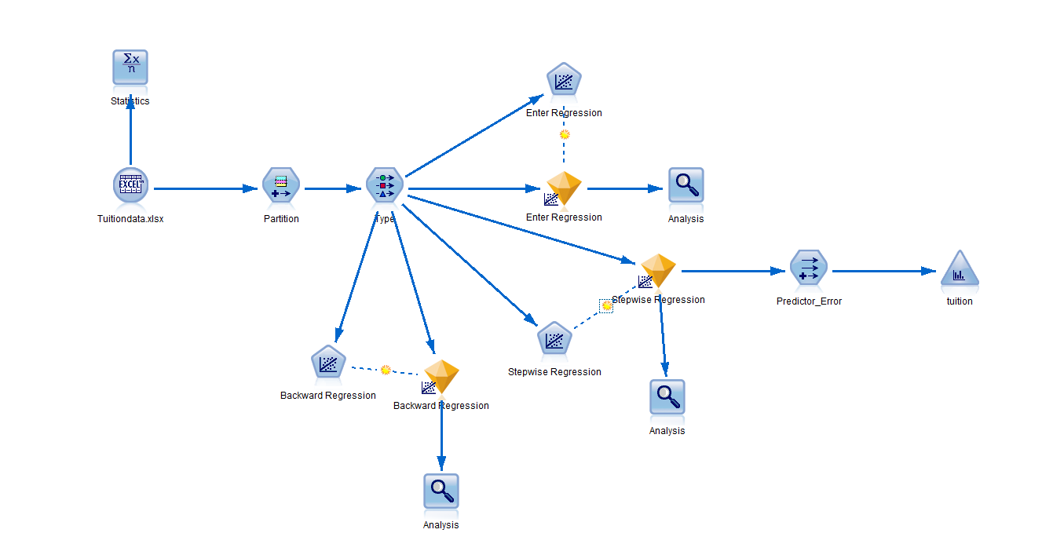

Stream for Question 10: 